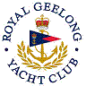 | Royal Geelong Yacht Club Inc.  Est 1859
Trophy Deed of Gift.

Trophy: | Philip Palfrey Memorial
Presented by: | Victorian Dragon Class Association Members
Date: | 1967
For: | Dragon Class: Jan Regatta Aggregrate
Remarks / Revisions | Internally Lit World Globe

